**Sample Sponsor Assignment Letter – Be sure to change all the underlined details and fill in your GS Team names and phone numbers. Fill out the chart at the end with your whole group’s information.**

**------------------------------------------------------------------------------------------------------------------------------------------------------------------**

Welcome to the Back-to-Basics

April-May 2023, 1:00 pmGroup***!!!***

Congratulations for being “ALL IN” for the commitment to fasting from all unnecessary media while working all 12 steps with an abstinent sponsor.

**Below you will find contact information for your sponsor.** Get ready for a wild and wonderful ride!!

Pleasecontact your sponsor this weekend and start to do your assignments.  By the way, all your assignments and our meeting formats are listed on the website.  The link is here:  <https://www.mediaaddictsanonymous.org/>. Go to the menu item Intergroups and choose “Month One” (or Month 2 or 3, as appropriate).  You will be asked you for a password which is: **couragetochange**

**The assignments for your entire month are there!**

**Attend a Home Group!**Please choose a MAA home group meeting from the meeting list on the website and after about a week of fasting start sharing. Get known! Ask for phone numbers! Leave your number for outreach!

Looking forward to seeing you on *Monday* on our Zoom meeting.  **Please arrive at 12:40pm ET** if you want to engage in fellowship and sharing prior to our meeting!  Most members find it helpful to arrive early to get to know your group and be settled in before the meetings start.

Everyone is required to**be on zoom by 12:50pm and we will begin the meeting promptly at 12:55pm.**  Please review the Commitments for Back-to-Basics (attached below) because there are lots of details in there. Talk to your individual sponsor or a group sponsor about anything you need clarified.  Also, feel free to reach out to other group members and the group sponsors for outreach and support.

As a reminder, here is the link for our Zoom meeting. Save this somewhere because you will be using it for every meeting we have…

<https://us02web.zoom.us/j/89080633714?pwd=WGJIeFdOOGQ0MHRlTWNOeXc4ekMwdz09>

Meeting ID: 890 8063 3714

Passcode: 717171

Sincerely,

Your Group Sponsors:

Ex: Elaine O, Memphis +1 555-555-5555 (CT)

Name/Location Phone

Name/Location Phone

Name/Location Phone

**PLEASE ATTACH A TABLE BELOW WITH THE FOLLOWING INFORMATION:**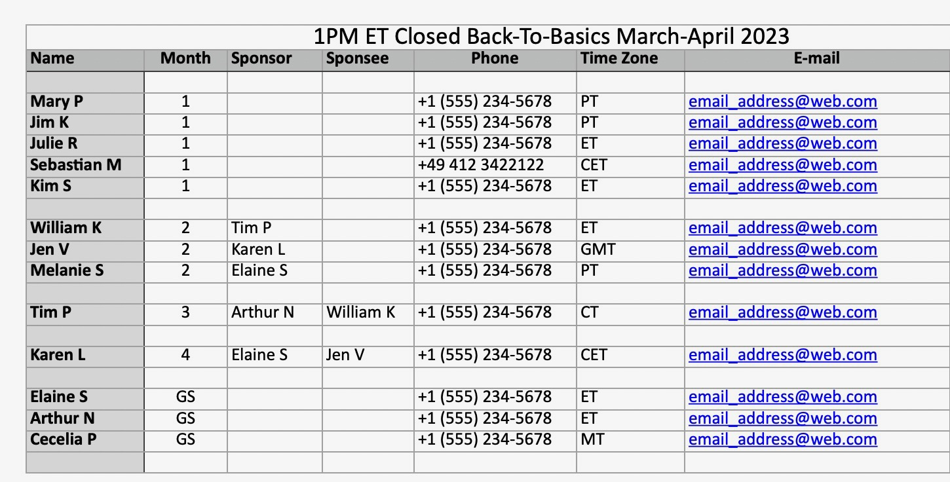

P.S. Everyone has been added to a **WhatsApp Group** for us to use for support.  People generally use it to be accountable with media that they need to use for necessary reasons.  Please be aware that we try to keep it non-specific so we don’t trigger anyone.  For example, “getting on media for 15 minutes for research,” rather than saying what sites I am going to visit.  *Thanks for your cooperation!!*

Let us know if there are any corrections to the contact information in the list above.

**ONE MONTH COMMITMENTS FOR**

**BACK-TO-BASICS, A DESIGN FOR LIVING**

**Closed, Committed 12 Step Media Sobriety Groups**

1. **MEDIA FASTING MEANS USING ONLY NECESSARY MEDIA:** We are beginning or continuing to fast from all unnecessary media as of right now. We will go into more detail as to what we mean by media fasting in a few minutes.
2. **MEDIA FASTING PLAN:** As part ofyour Media Fasting Plan, please write down all your compulsive "alcoholic media'' and discuss this with your sponsor as soon as you are assigned one. You need to know your drug of choice to be sober. Clarity and honesty are your keys to freedom. *When in doubt, leave it out*.
3. **ASSIGNMENTS:** If you haven’t already done so, please do your best to complete all pre-commitment assignments before the first meeting with your sponsor. These assignments should have been sent to you. If you don't have them, please let the Group Sponsors know.
4. **SPONSOR:** You will be assigned a sponsor. This is the person who will hold you to your commitments and mentor you through the 12 Steps. This may or may not be an ideal match, but we are here to learn from each other. Trust that every person has something important to teach you. Set aside anything you may think you know about recovery and working the Steps and stay open to the miracles that can happen. You are responsible for keeping up with homework, calling your sponsor to schedule meetings, and for showing up on time.
5. **ATTEND ALL MEETINGS**: By committing today to this one-month closed group, you are agreeing to attend ALL Back-to-Basics meetings every weekday. The meetings will last approximately 30 minutes Mondays through Thursdays, and we meet for a full hour on Fridays. We go through the 12 Steps quickly. If you miss a meeting, you may miss a whole step. Sometimes emergencies arise (such as births and deaths), and if you need to be excused for any reason, please talk to BOTH your sponsor and to the Group Sponsors. Please don't message members about scheduling issues in your B2B WhatsApp group. Please use the "sponsor channels" for any emergency. Missing a meeting without okaying it first with the group sponsors constitutes a slip.
6. **BE SEEN:** All meetingsare held on Zoom. As media addicts, we have hidden behind screens and have isolated ourselves. Part of recovery is to be seen and to bond with your group; therefore, one of the commitments you will make today is to agree to turn your camera on and be seen throughout the course of meetings.
7. **BE ON TIME:** Arrive at every meeting at least **10 minutes early** so the meeting can start on time. If you are more than 10 minutes late, this will be considered an absence, and you will need to do make-up work for the missed portion.
8. **OPTIONAL OPEN GROUP SHARING:** The Zoom room will open 15 minutes before our B2B meeting starts. This is a time fellowship and open sharing. This isn’t a requirement, but this pre-meeting time is a way to get to know other group members and support each other. Many of us grow very close, because we reach out and share. *When you speak of your experience during fellowship time and in all our meetings, please refrain from swearing while sharing*.
9. **ATTEND MAA MEETINGS**: Chose at least one MAA meeting to attend regularly for the duration of the month, so you may hear others share and so you may give your own experience, strength, and hope. Please volunteer to serve at these meetings by reading, keeping time, and sharing.
10. **COMPLETE ALL ASSIGNMENTS**: By joining B2B, you commit to completing all assignments and to reading them to your sponsor and, where appropriate, to other members of the group.
11. **CALL BEFORE YOU USE**! More than likely, you will have moments when the craving to use media is overwhelming. Today you are committing to calling your sponsor or someone else in the group if you feel the need to use unnecessary media. CALL BEFORE YOU USE! Also, fill out the Urge Surfing worksheet located in your packet. It really helps. Ask your Higher Power to remove your compulsion to use media. This also really helps. Say the Serenity Prayer. Have faith. You can do this!
12. **RELAPSE**: You may have noticed we take our sobriety seriously. In B2B you are committed to fasting from all UNNECESSARY media. If you relapse (meaning you use your addictive bottom-line media and end up in a media binge blackout), you may not be ready to work this intensive program. We have a disease: It is not a moral issue, and we don't judge anyone for relapsing. This is the main reason we come together: to hold the space of sobriety and recovery for each other. With love and for the sobriety and health of the group, if you find you are unable to stay on your fast, we sincerely ask that you bow out of the group until you are ready to make this kind of commitment. We are a closed group for this reason. You are free to rejoin us or another Back-to-Basics group when you are ready. Please let your sponsor and the Group Sponsors know if you need to step out. Please keep this information to yourself until you speak with the Group Sponsors.
13. **SLIPS**: If you have a slip (meaning you have a momentary lapse in your media middle or bottom lines), talk to your sponsor **immediately**. If you are having multiple slips—one after the other—then you may not be ready to work this kind of intensive program. For the sobriety and overall health of the group, if you continue to slip, again, with love we ask that you bow out of the group. As stated earlier, missing a meeting, or not showing up on time, is also considered a slip.
14. **NOTIFY YOUR SPONSOR IMMEDIATELY**: Slips or relapses are to be discussed **with your sponsor only**. Please don't share them with the rest of the group. We are all fragile in our early recovery, and we need to keep a positive sobriety message as we carry each other through withdrawal and the grief that can show up when we let go of our beloved media.
15. **SOBRIETY IN ALL OTHER PROGRAMS**: Remain abstinent and sober in all your other recovery programs while you are on this fast. If you find yourself turning to other substances which you never addressed with a 12-step program, bring this up with your sponsor and with other members to learn from their experience, strength, and hope. This is a natural occurrence but needs to be addressed as soon as possible, to explore possible next actions. The Big Book tells us that a person needs to be sober to work the Twelve Steps. If you are abstinent from media but still abusing food, drugs, or alcohol, it's hard to honest enough to work the Steps effectively. Honesty is key to meaningful recovery.
16. **OUTREACH CALLS**: Make **two or more** outreach calls per day. One could be to your sponsor and the other to someone in your B2B group or someone you heard at a media-related meeting. **Reaching out to newcomers is important.** Please share your experience, strength, and hope as often as you can.
17. **BOOKEND**: Use the group to bookend hard-to-handle media that you must use for work or other necessary reasons. We recommend you bookend all middle line media usage (such as online research or instructive YouTube viewing) with the WhatsApp B2B group or via a phone call. Please do not mention specific types of media in the WhatsApp group. Rather, say something like, “bookending my media for 15 minutes.”
18. **GROUP CONNECTIONS**: Because any type of media will be triggering for some members, we limit email and WhatsApp correspondence to requests for outreach, bookending media usage, and giving timely information from the group sponsors to members as necessary. Please DO NOT post links to websites, photos, books, or share generic "words of wisdom." In group meetings please don't mention outside issues by name. Instead, use outreach calls to share what is personally meaningful.
19. **ATTEND THE SATURDAY B2B QUALIFICATION CALL**:Please attend or listen to the recording of Saturday Qualification Calls (2:00 PM US ET). It is important to hear and learn from those with solid media recovery. These meetings will do a lot to inspire and help you with your fast. If you are not able to attend, please listen to the recordings at http:// www.mediaaddictsanonymous.org. After one month in Back-to-Basics, you may be asked to qualify at one of these meetings. Please consider accepting this request for service.
20. **SLEEP REVERENCE**: Set a time to go to bed and a time to wake up every day. By doing so, you will have more emotional energy to get sober and stay sober this month. Share these pre-set times with your sponsor to stay accountable.
21. **MEDIA SHUT OFF TIME**: Set a time to be off all media at the end of the day and the time you will start media at the beginning of the day. Discuss this “media curfew” strategy with your sponsor.
22. **NATURE WITHOUT MEDIA:** Every day, take at least 15 minutes to walk in nature without your phone.
23. **FASTING REMINDERS:** Make two little signs that read the following: “IS THIS REALLY NECESSARY?” and “WHEN IN DOUBT, LEAVE IT OUT.” Keep these reminders close to your phone and computer.
24. **REMEMBER TO HALT**: If you get too Hungry, Angry, Lonely, or Tired, which may put you at risk for a slip or relapse, call someone in your group or the larger MAA fellowship.
25. **DONATION:** We ask all group members to make a donation to MAA as part of their contribution to this group. MAA allows us to use their Zoom account and website. The suggested donation is $20. If you are unable to donate the full amount, please donate whatever you can afford. No one will be turned away. Donations can be made at [www.mediaaddictsanonymous.org](http://www.mediaaddictsanonymous.org).